**Deployment of java application in multiple tomcat servers using jenkins**

1. Launch EC2 instance (Ubuntu) Install Below Requirement’s in EC2 Instance.

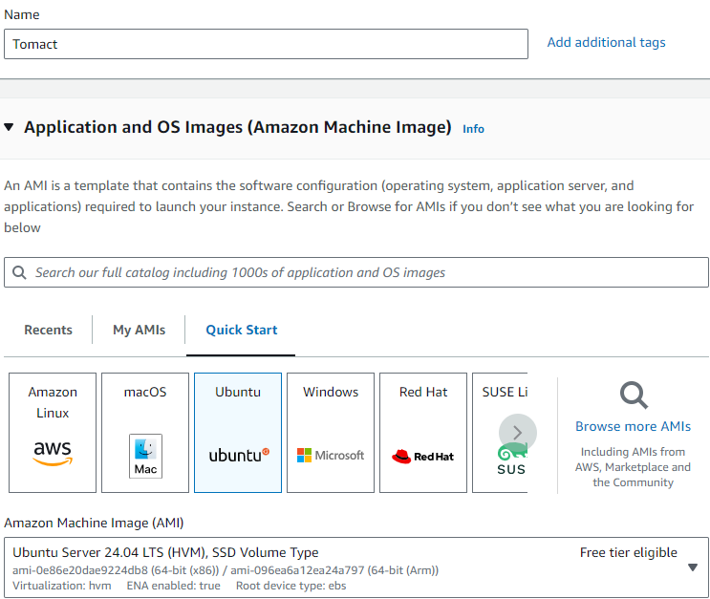

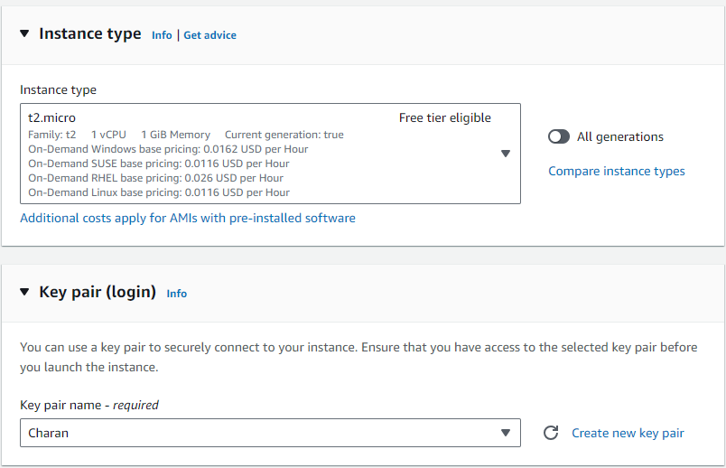

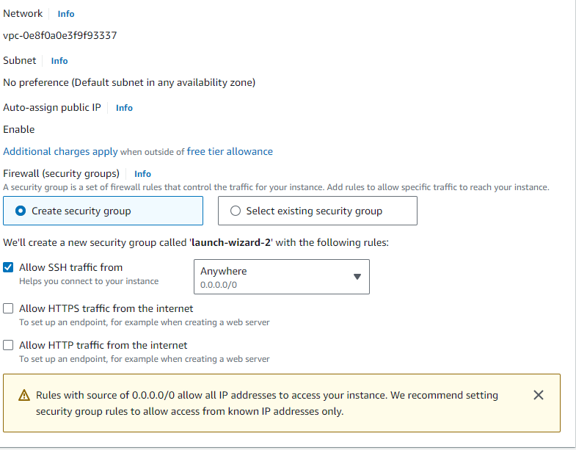

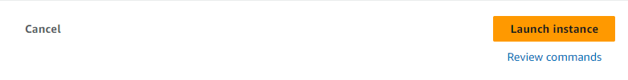

* Launch instance & Connect to the instance in git bash

**Update and installing** java & **maven & tomcat server**

* **sudo -i**
* **apt update -y && apt install default-jdk -y && apt install maven -y**



* **java –version && mvn -version**

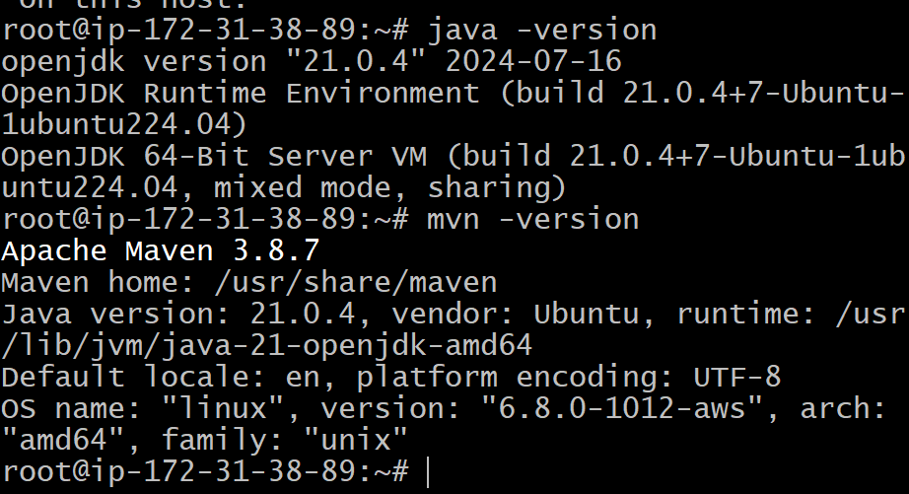

* **download the tar file of tomcat from browser with \**
* **wget https://dlcdn.apache.org/tomcat/tomcat-9/v9.0.93/bin/apache-tomcat-9.0.93.tar.gz**

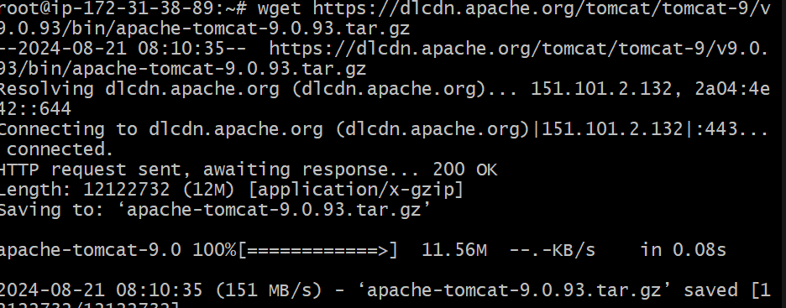

* **ls**

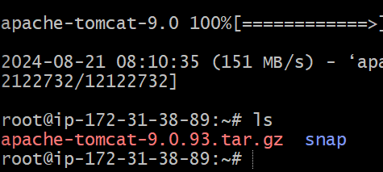

* **apache-tomcat-9.0.93.tar.gz snap**
* **tar -xvzf apache-tomcat-9.0.93.tar.gz**

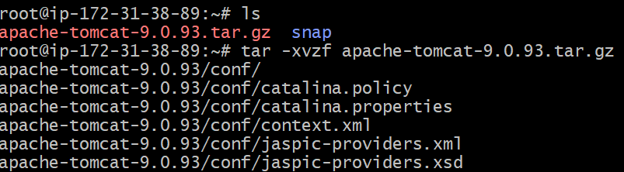

* **mv apache-tomcat-9.0.93.tar.gz Tomcat and click on ls**

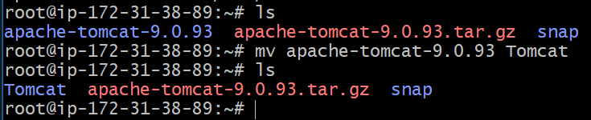

* **cd Tomcat**
* **ls**



* **cd conf**
* **vi tomcat-user.xml**
* **in tomcat-user.xml by default it will be as show below**

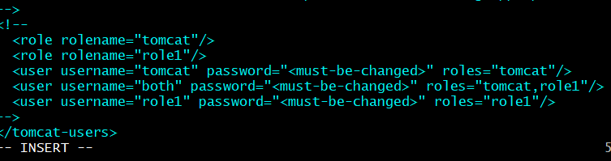

* **Add the manager-gui, manager-script, manager-jmx, manager-status. After adding the following**

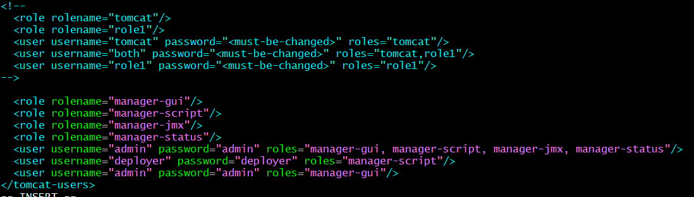

* **Exit the vi tomcat-user.xml**
* **Cd ..**
* **Cd webapps**
* **Ls**

**ROOT docs examples host-manager manager**

* **Cd host-manager**
* **Ls**

**META-INF WEB-INF css images index.jsp**

* **cd META-INF**
* **ls**

**context.xml**

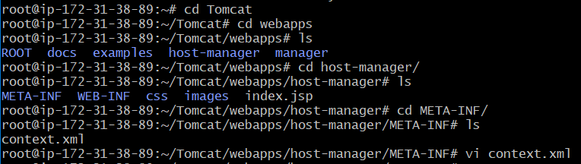

* **vi.context.xml by default it will be as shown below**

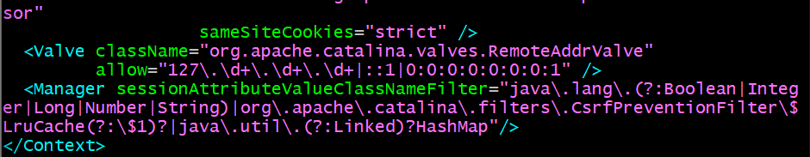

* **add the <! -- under the samesitecookes and add --> near the allows**

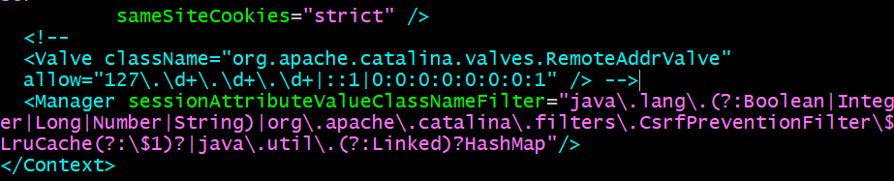

* **Exit the vi context.xml**
* **Cd ..**
* **Cd ..**



* **Ls**

**ROOT docs example host-manager manager**

* **Cd manager**
* **Ls**

**META-INF WEB-INF css images index.jsp status.xsd xform.xsl**

* **META-INF**
* **Ls**

**Context.xml**

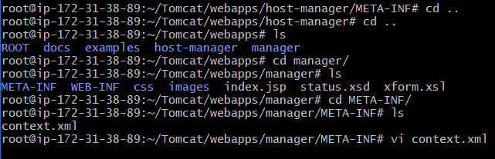

* **Vi context.xml by befault it will be as shown below**

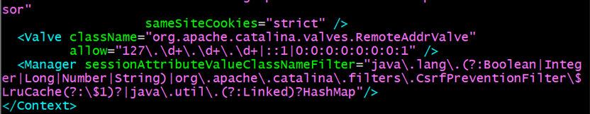

* **Add the <!--under the samesitecookies and add --> near allow**

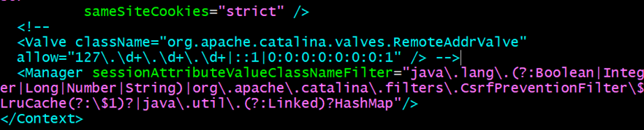

* **Exit the vi context.xml**
* **Cd ..**
* **Cd ..**
* **Cd ..**

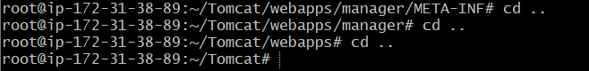

* **Cd bin**
* **Ls**

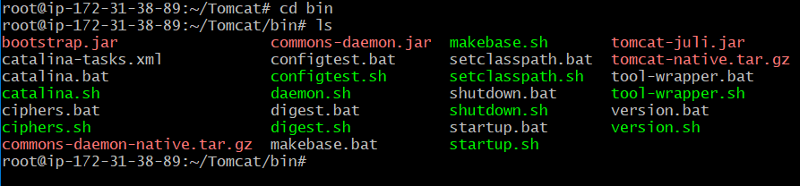

* **./startup.sh**
* **Now go to the security group which is assigned to the instance**
* **And add the port number :8080, Anywhere IPV4: 0.0.0.0/0**

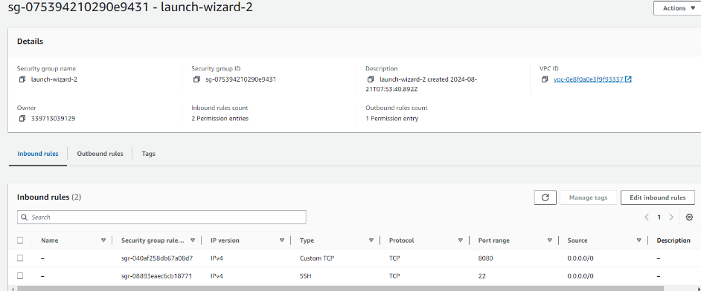

* **Now go to the instance copy the public ip (Tomcat -54.80.208.200)and past in the browser with the :8080 port number**
* **First click on manageapps**

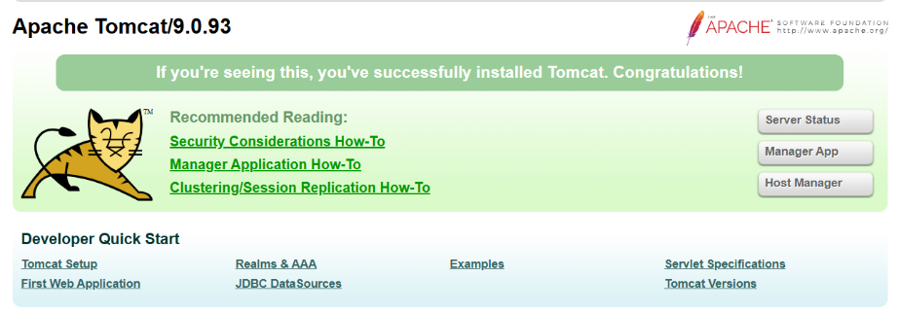

* **Click on the user and password**

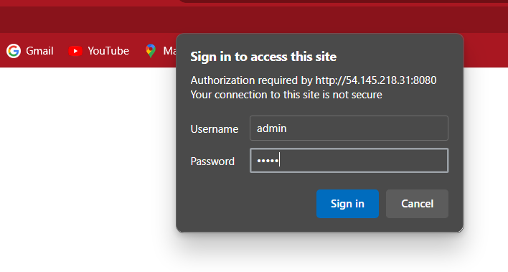

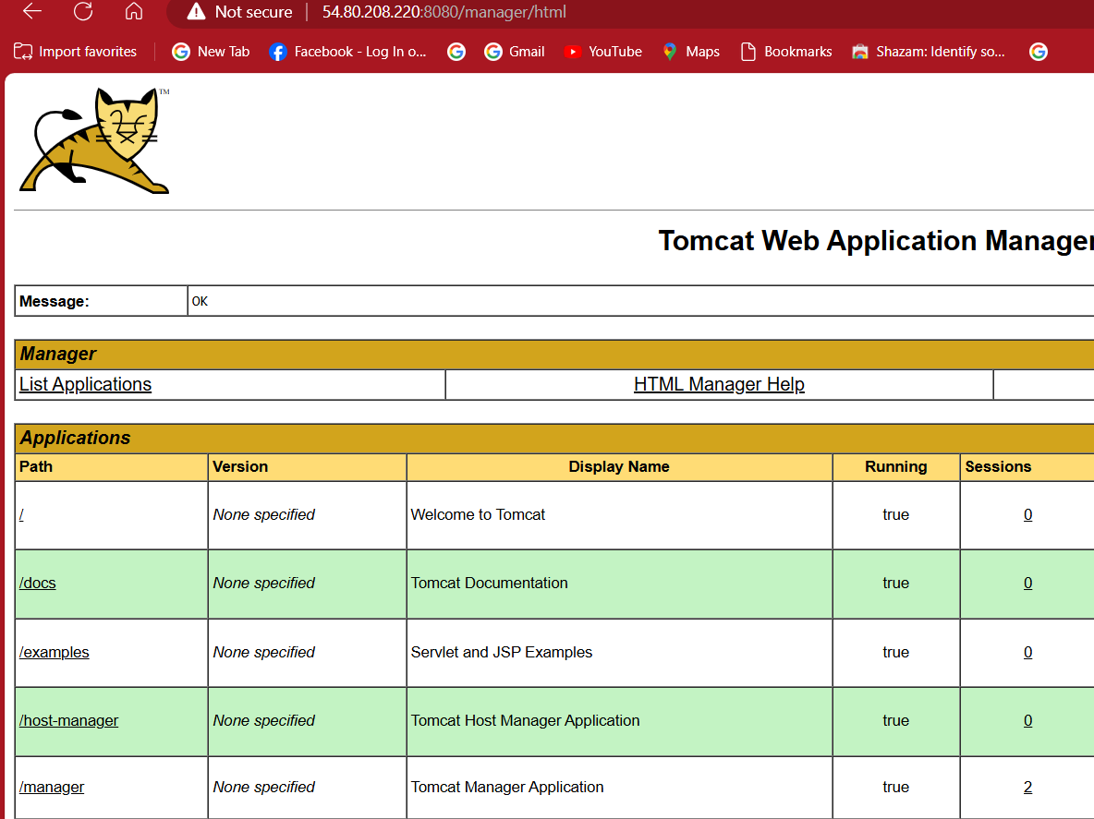

* **Next instance and create an image to the -(Tomcat instance)**

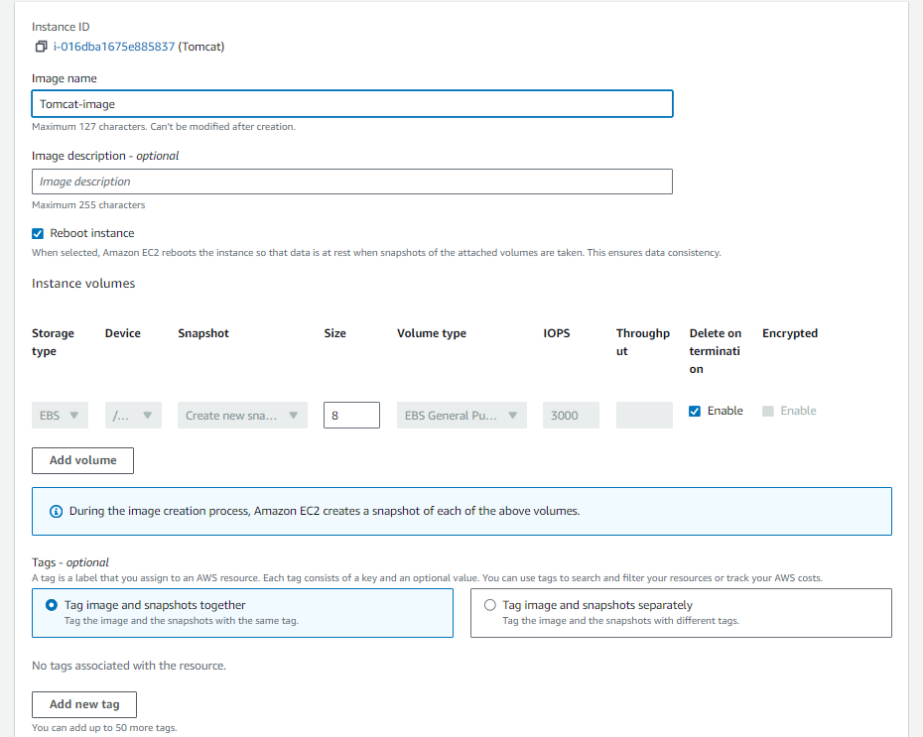

* **Click on create an image && name (Tomcat-image)**
* **After the image is create go to AMI**

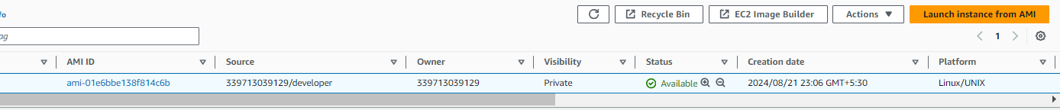

* **Next click on lunch instance from AMI (developer, test, production, pre-production)**

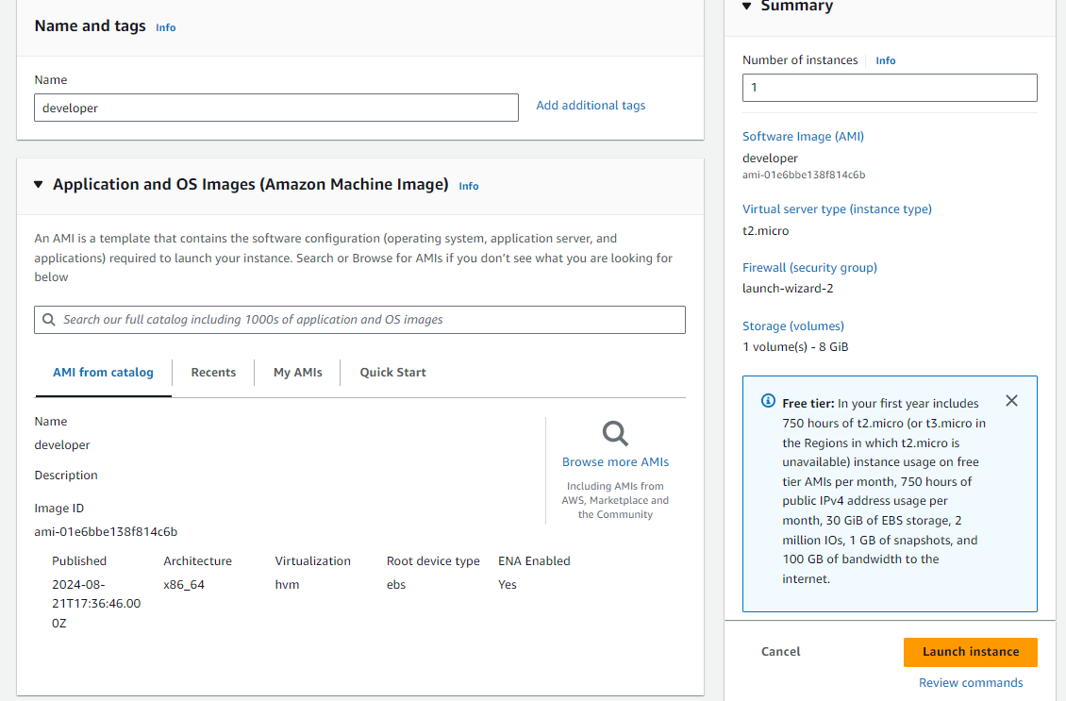

* **Create all in the same way using the AMI**

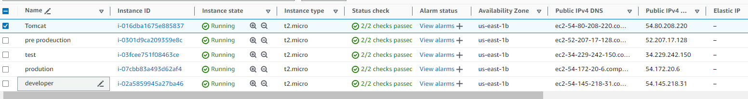

* **Now connect to all the instance which are created by the AMI image in the server**
* **Cd Tomcat**
* **Cd bin**
* **./startup.sh**

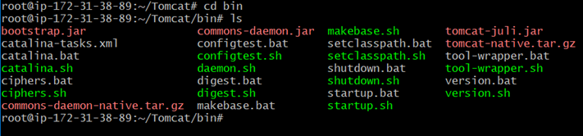

* **Do this process for all the instance (developer, test, production, preproduction). So that we can start the tomcat**
* **Next go the browser and past the public ip of the developer with :8080**

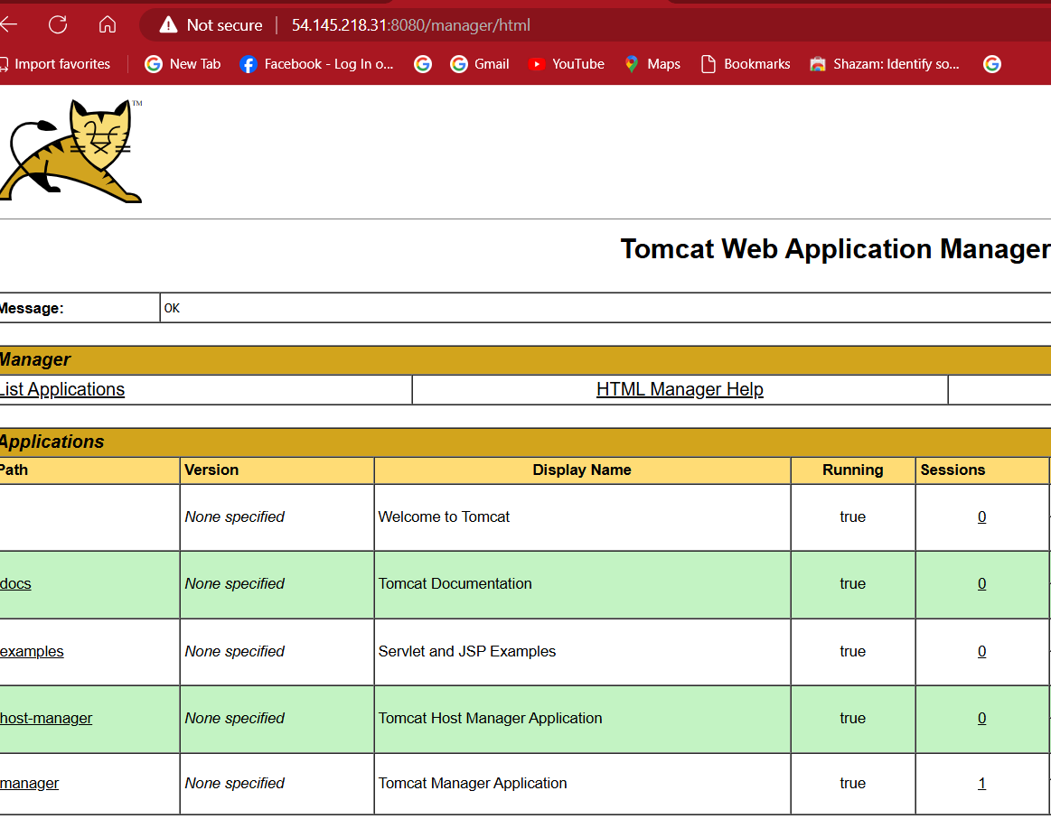

* **Next go the browser and past the public ip of the test with :8080**

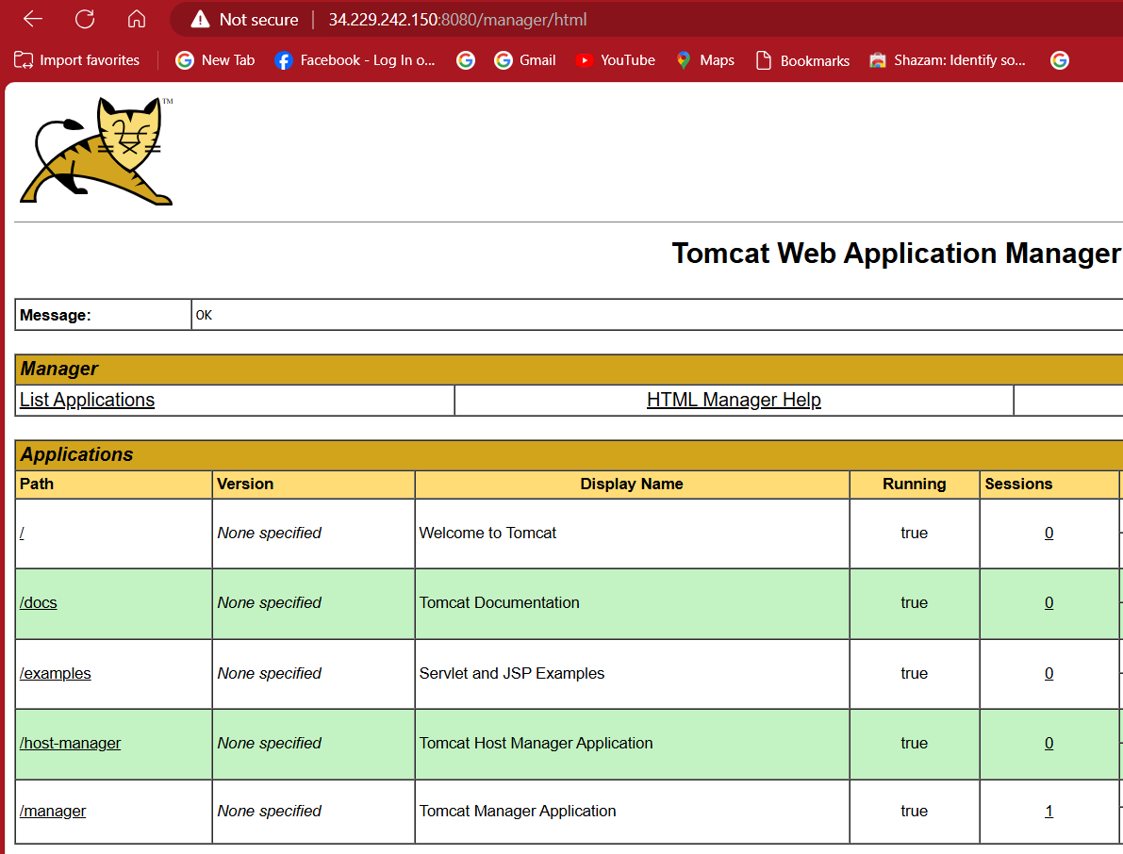

* **Next go the browser and past the public ip of the production with :8080**

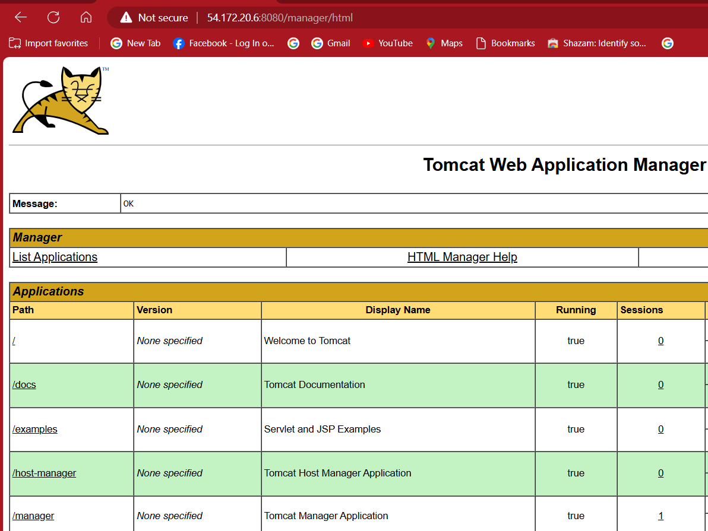

* **Next go the browser and past the public ip of the pre-production with :8080**

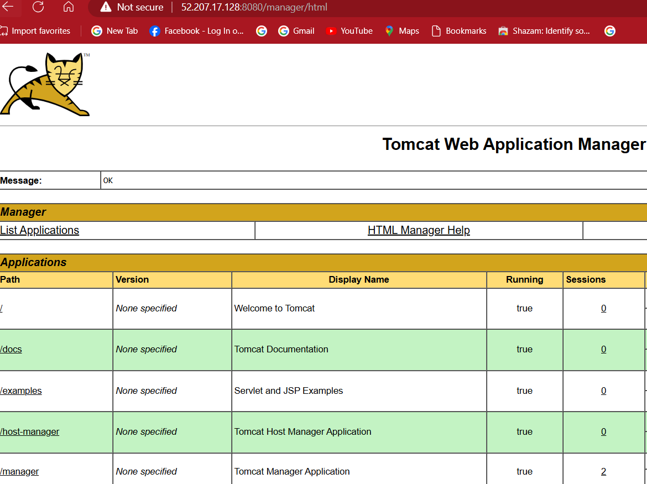

* **Now create an ec2 instance**
* **Ami – ubuntu**
* **Instance type – t2.large**
* **Add the key pair**

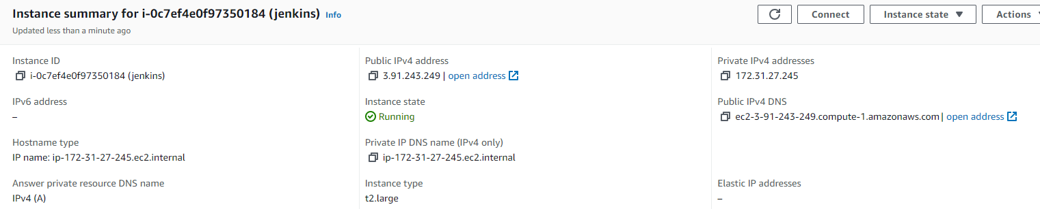

* **For installing Jenkins we need to install default-jdk & maven & jenkins**
* **Connect to the Jenkins**
* **apt update -y && apt install default-jdk -y && apt insatll maven -y**

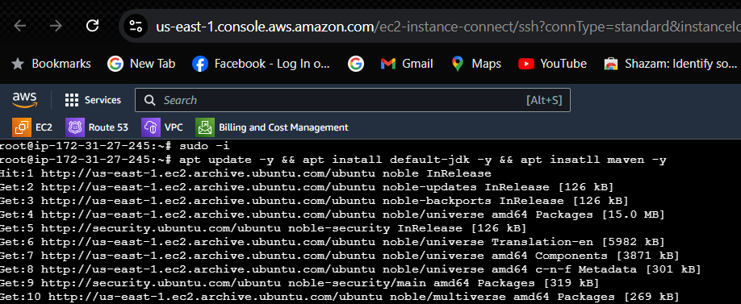

* **javan –version && mvn –version**

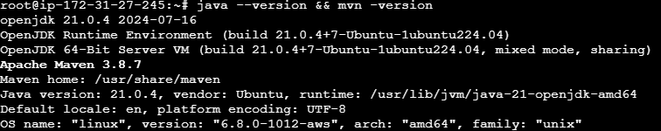

* **next install Jenkins for linux ubuntu get the installation cod from the browser**

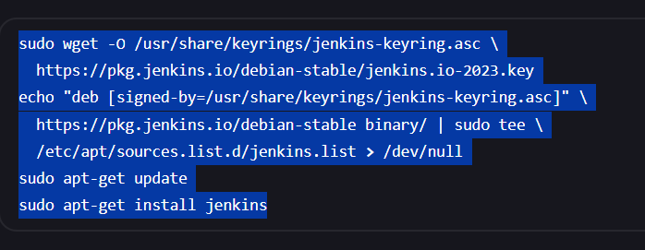

* **past it in the Jenkins server and click on enter**

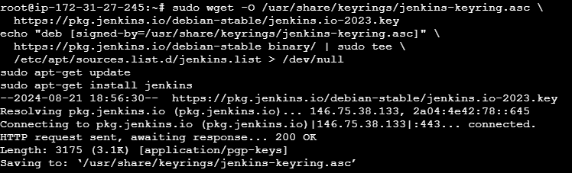

* **copy the public ip and add :8080 in the last in the browser**

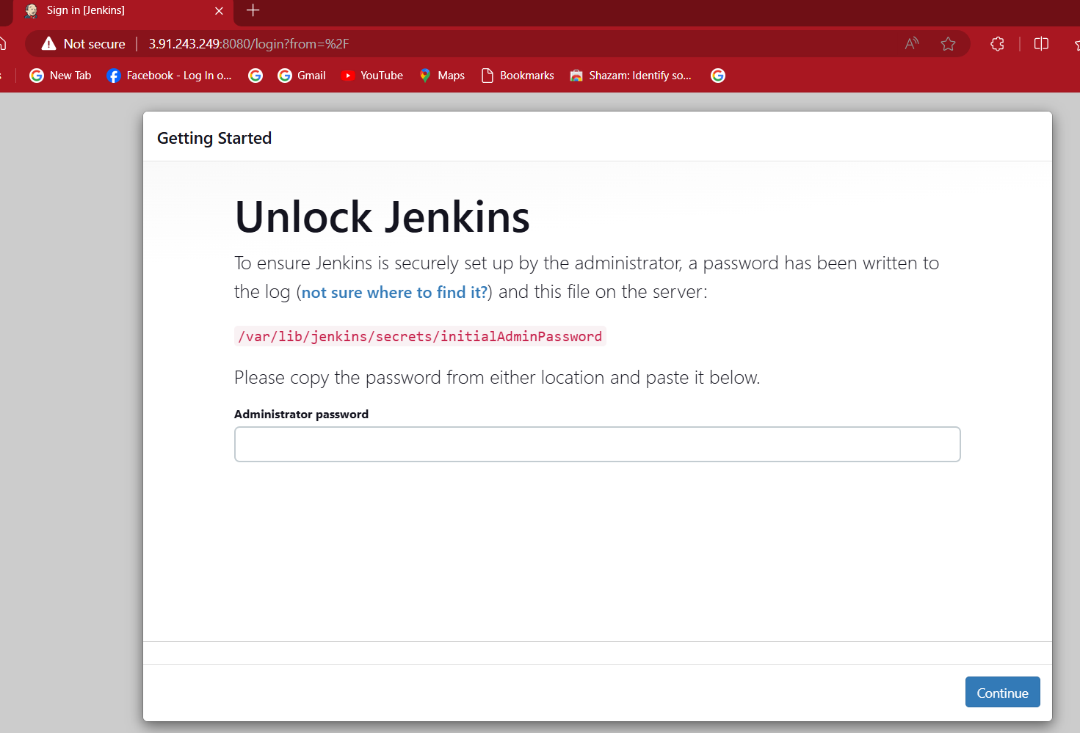

* **to get the administrator password copy the path and view the file using cat /var/lib/jenkins/secrets/initialAdminPassword in the Jenkins server**

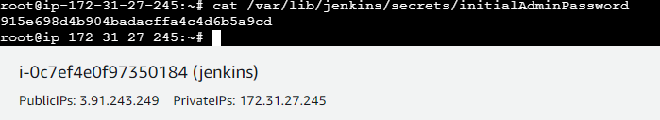

* **copy the password and past it in Jenkins**
* **click on start**

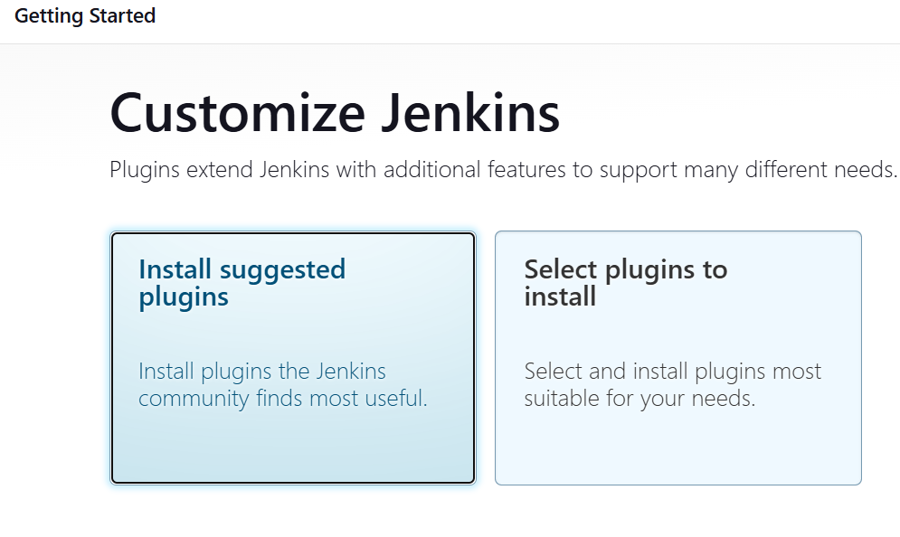

* **click on install suggested plugins & give the name, password, username, email**

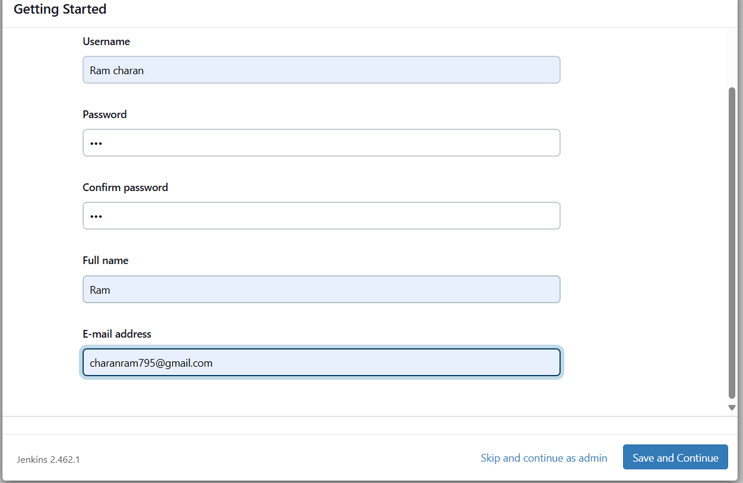

* **click on save and continue & click on start using jenkins**

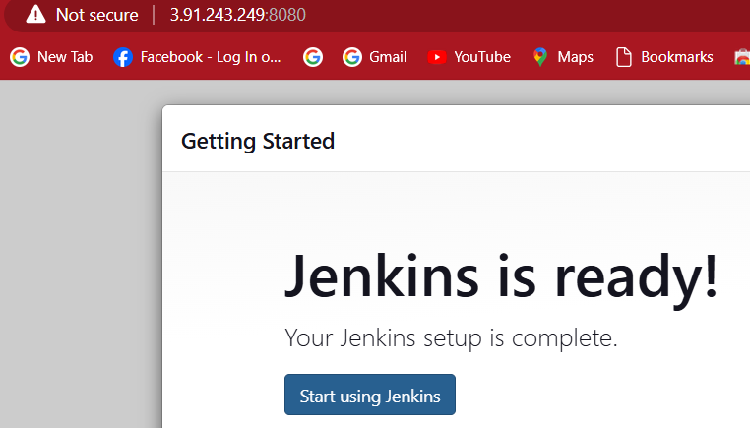

* **After opening Jenkins dashboard click on manger Jenkins**

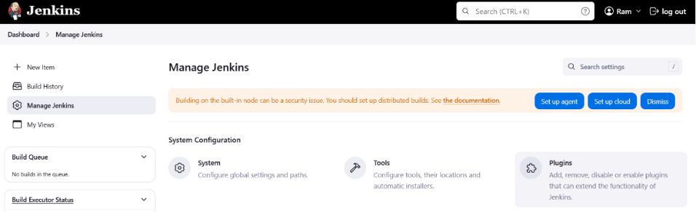

* **Click on plugins**
* **Download the deploy with container in Jenkins and click on insatll**

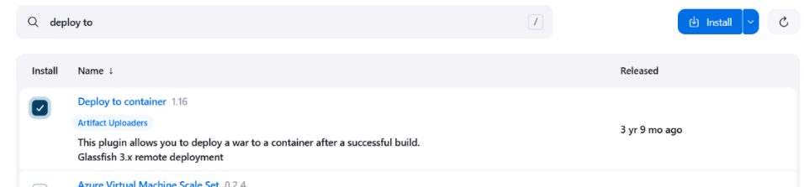

* **Next restart the Jenkins server to install the plugin**

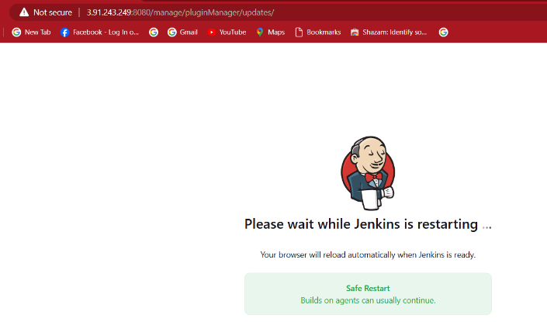

* **Next create a new job-(project) with the pipeline and click on ok**

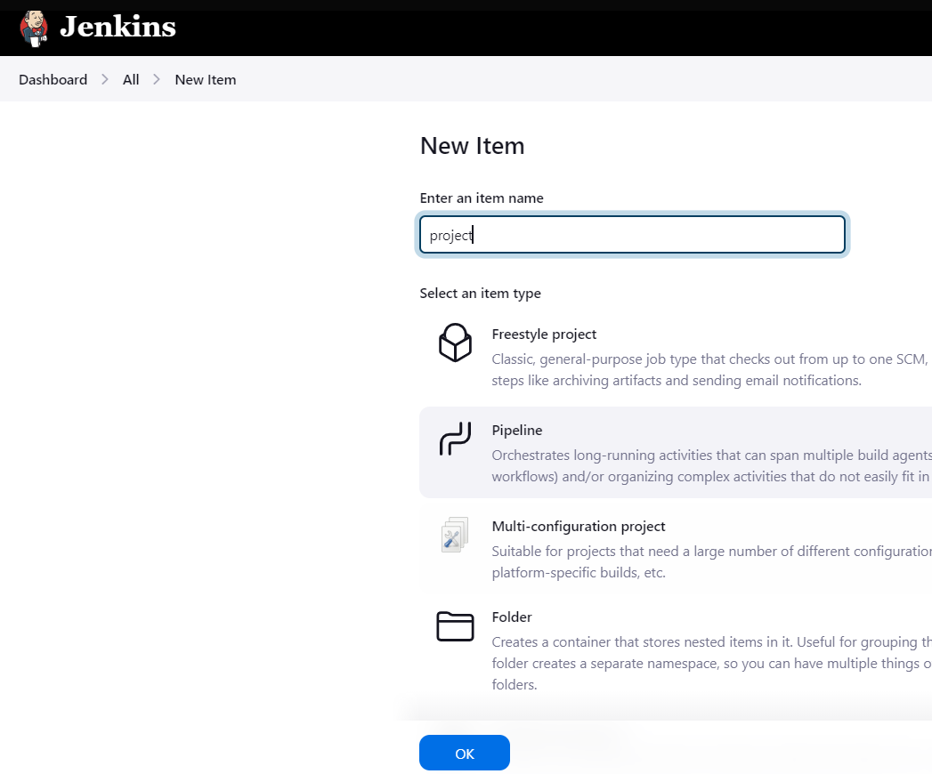

* **Next go the pipeline script it shows a block to write the script**

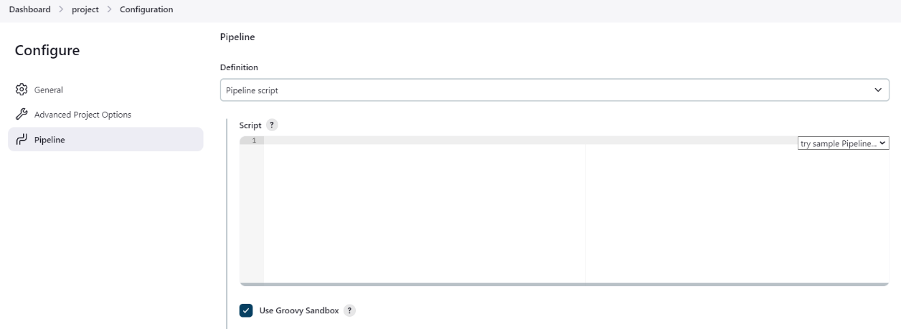

* **This is a basic syntax common in all the pipeline script to clone a repository from the git hub**

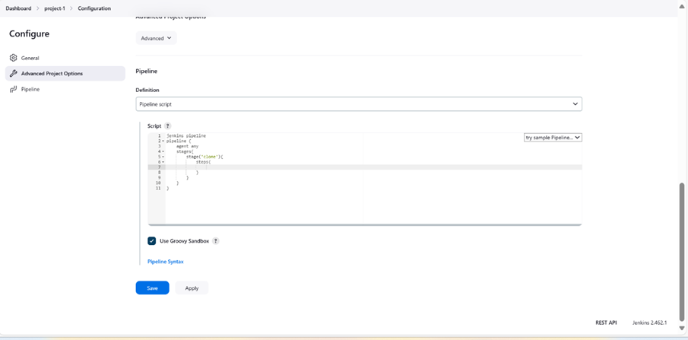

* **To get the shell script to clone click on pipeline syntax**
* **Select the checkout: Check out from version control**

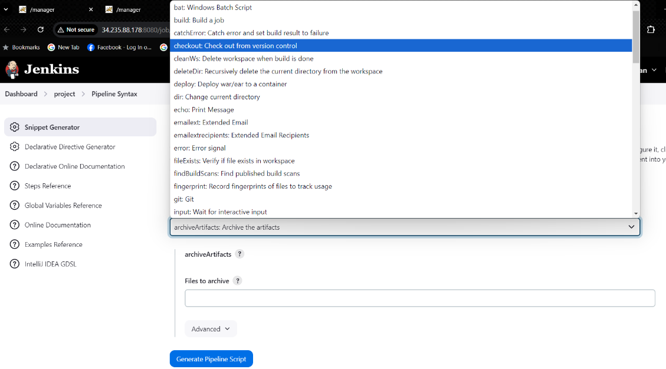

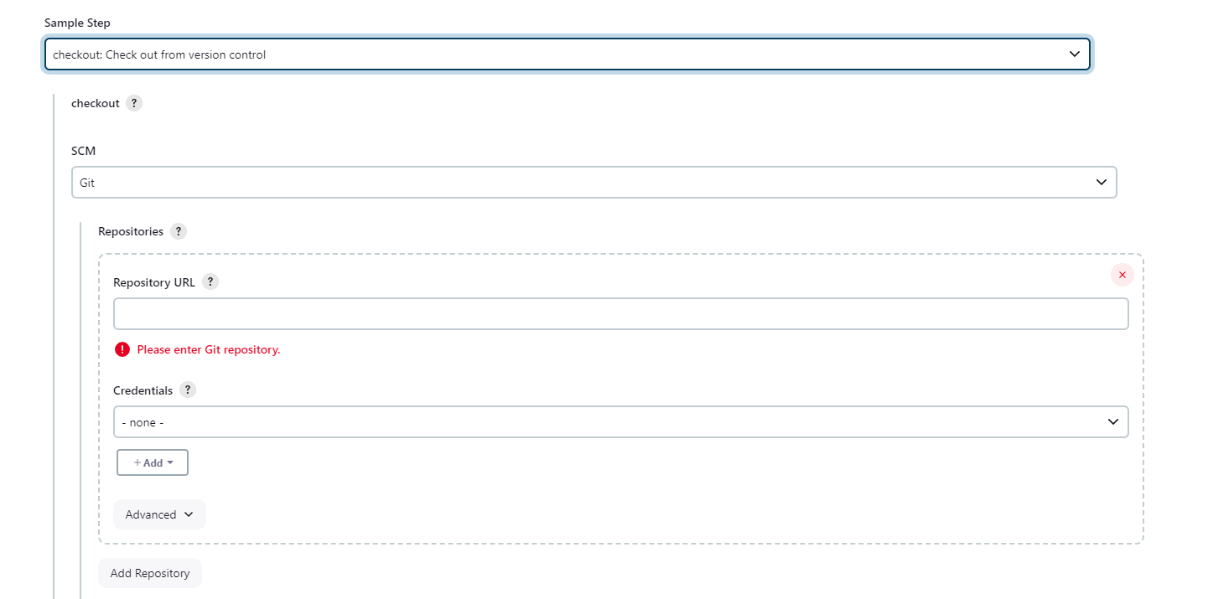

* **Next add the repositories URL here in the Respository block and if you repository is private you need to give the credentials.**
* **Copy the URL of your repository in the git hub.**

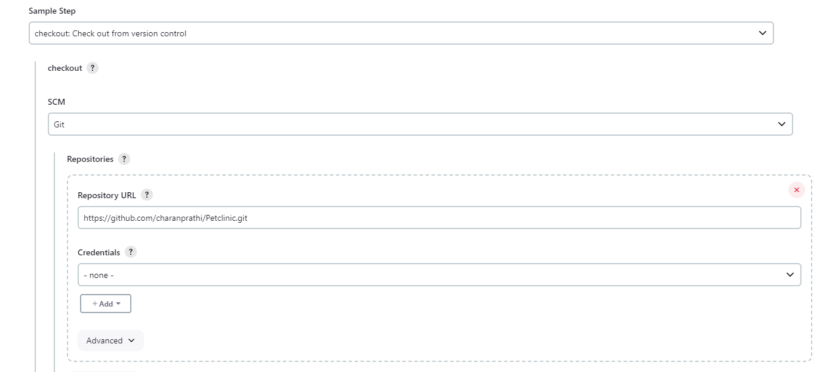

* **If the repository is public no need to give the credentials and branches to build in */master**

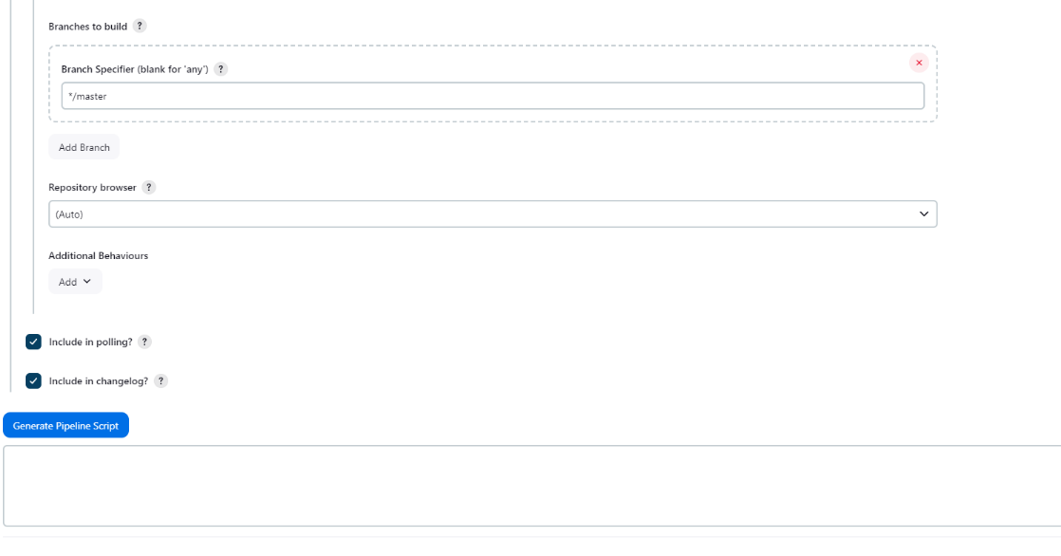

* **Now click on generate pipeline script and past in the clone steps in the pipeline script**

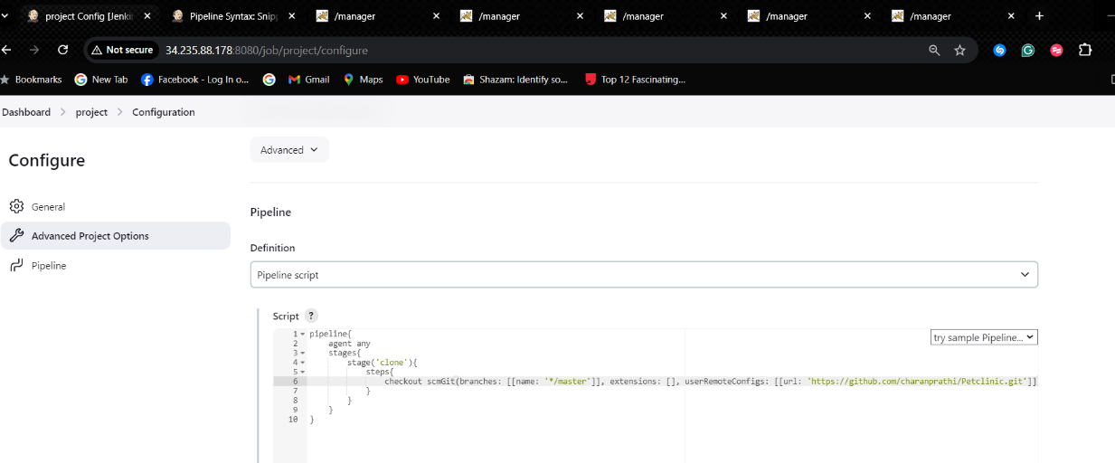

* **Add the stage of validate, test, compile, package in the shell script as shown below**

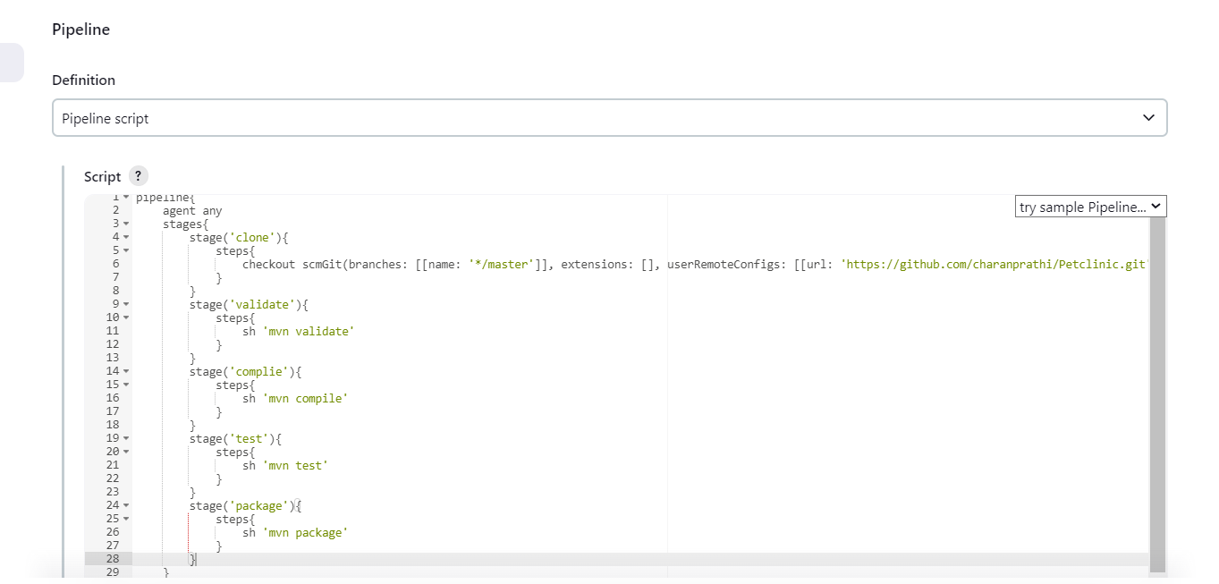

* **Next add stages to deploying to multi tomcat servers by pipeline script to generate a shell script using deployer war/ear to a container plugin which we previously installed in Jenkins**

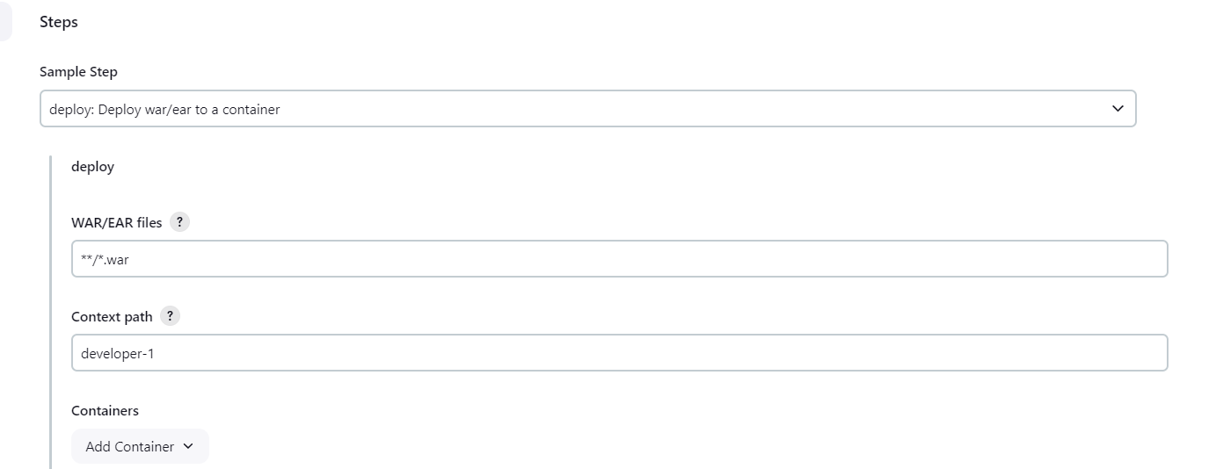

* **Click on add container – tomcat*9 Remote**

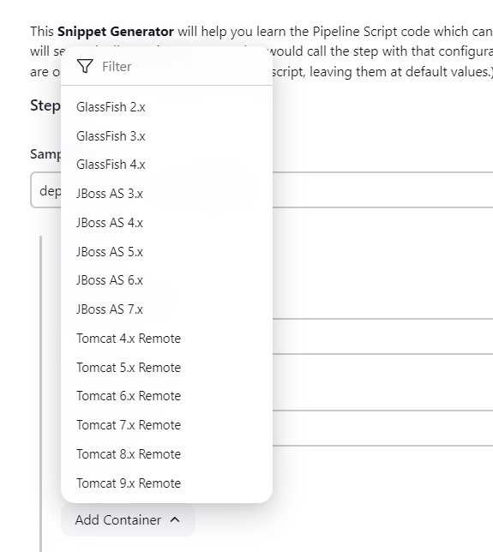

* **Now we need to give the credentials of tomcat and click on add**

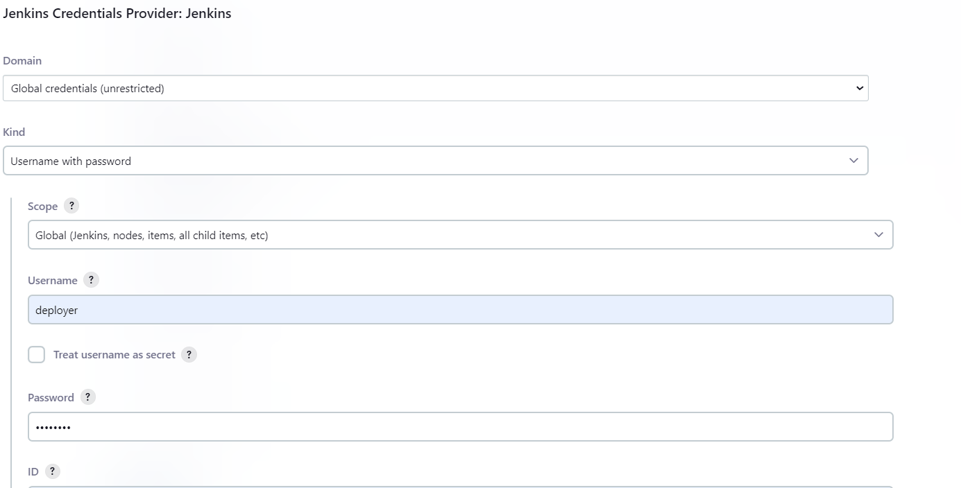

* **we need to give the tomcat URL to which server we need to deploy**

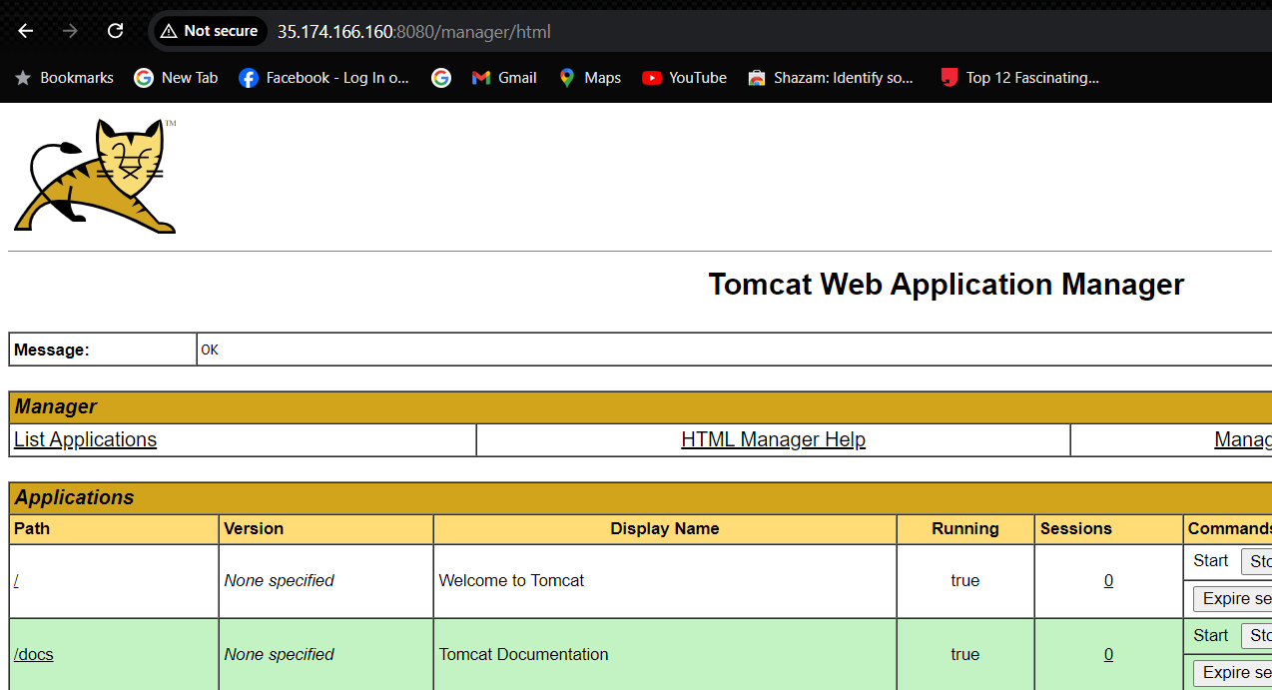

* **past the URL in the Tomcat URL section and next click on generate pipeline script**

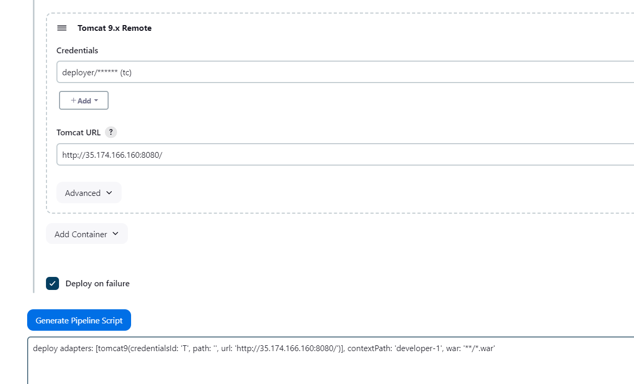

* **Next write another stage to deployer to tomcat server by coping the shell script as shown below**

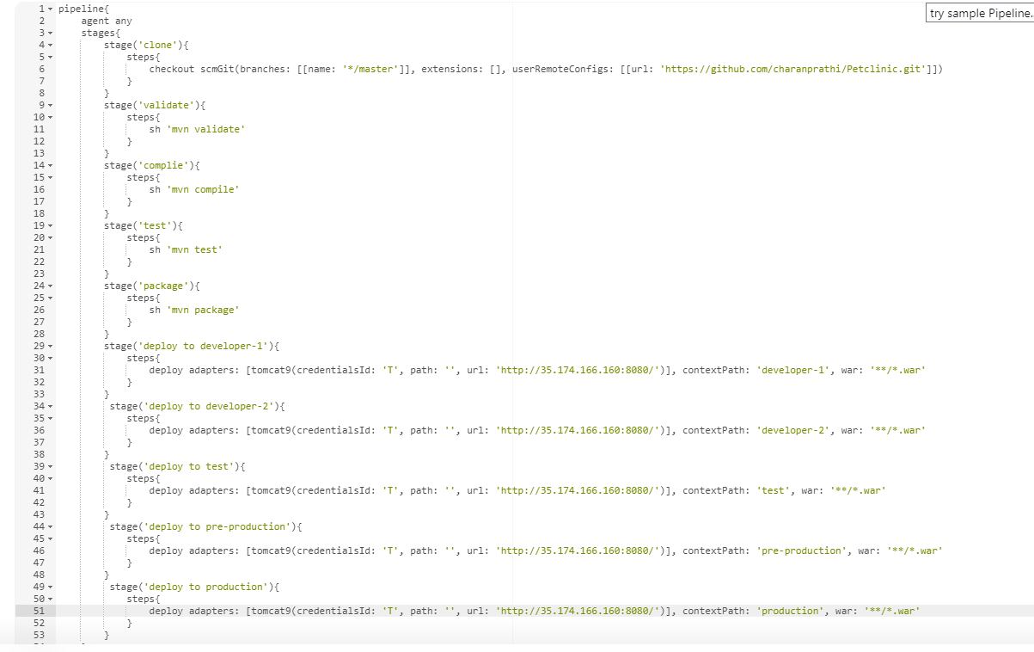

* **Create the pipeline syntax in the same as shown in the above picture for all the tomcat server**
* **Here I have 5 tomcat servers so I added then all in the stages to deploy application in the tomcat**
* **Now click on save and apply**
* **Before you click in build make sure that all your tomcat servers are in logon state if not it won’t deploy to your servers**

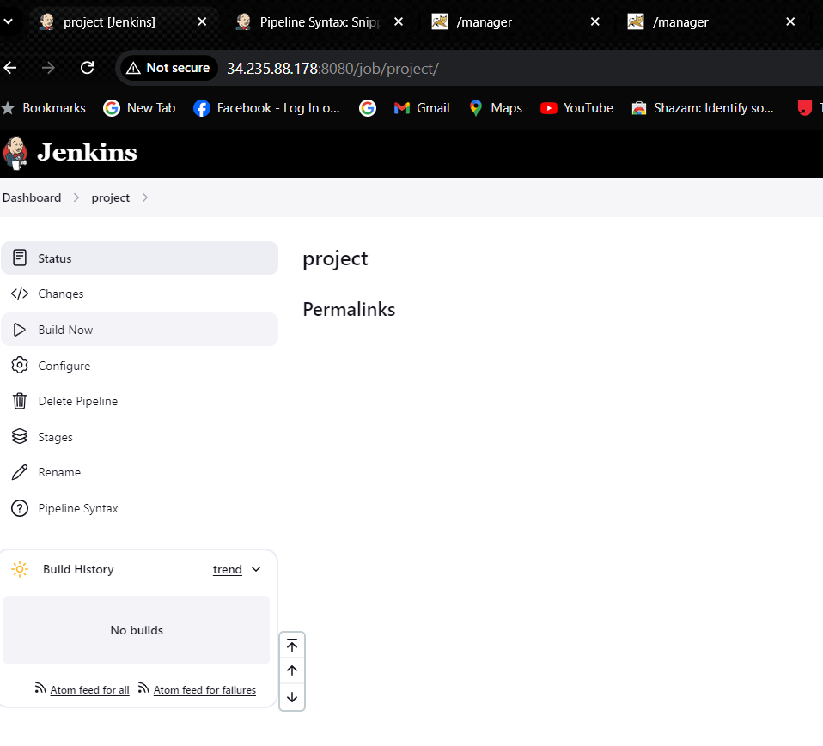

* **And click on Build now open stages to see the deployment**

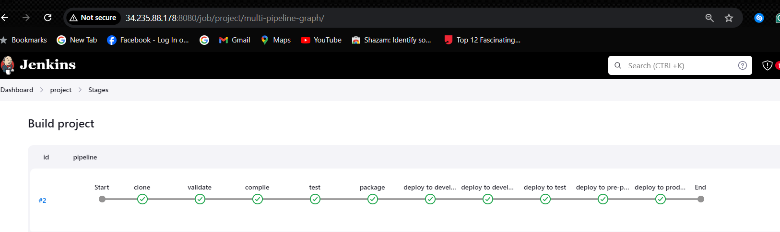

* **Now let’s check the tomcat servers one by one that the application is deployed or not**
* **Developer-1 in the first server (**[**http://35.174.166.160:8080/**](http://35.174.166.160:8080/)**)**

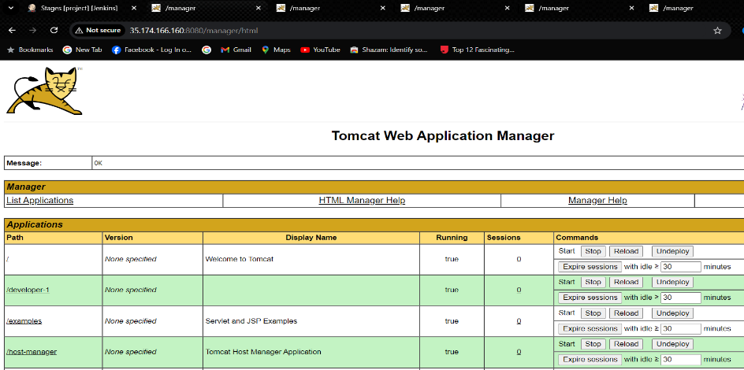

* **Now click on the developer-1 to see the application**

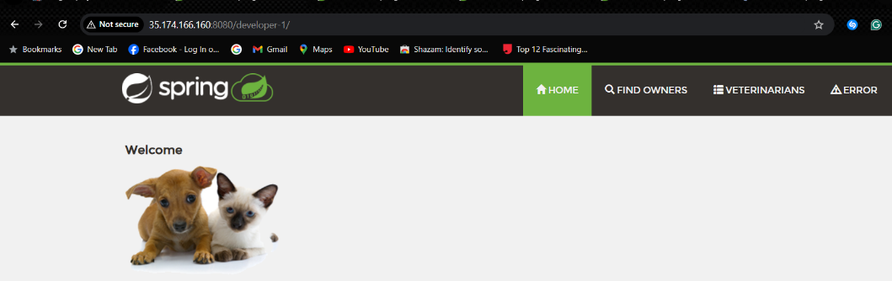

* **Developer-2 in the second server (**[**http://54.146.159.251:8080/**](http://54.146.159.251:8080/)**)**

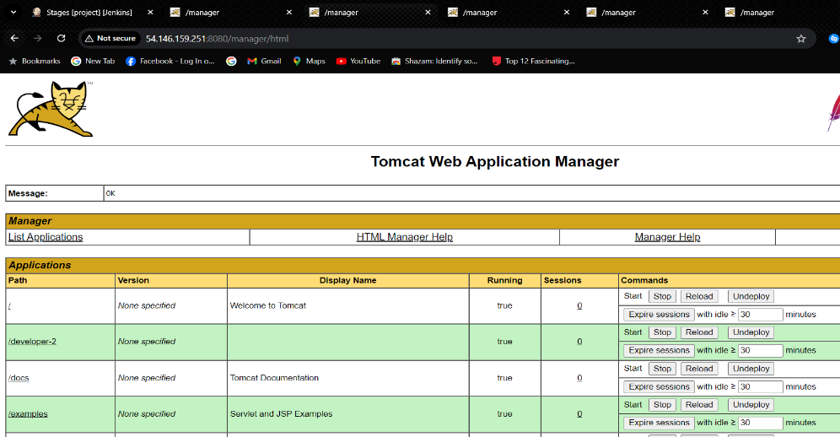

* **Now click on the developer-2 to see the application**

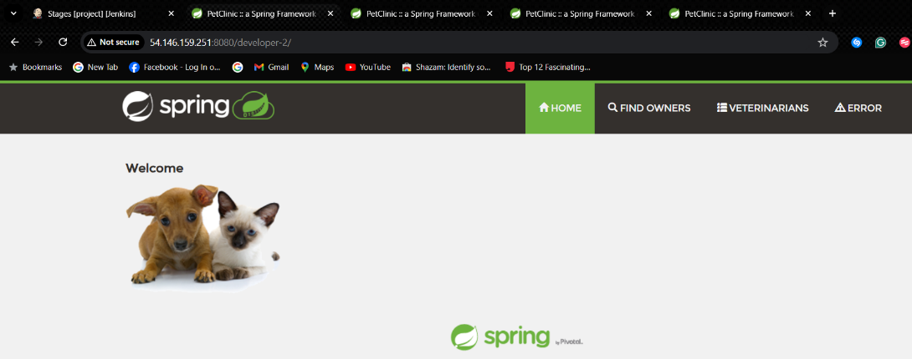

* **Test in the third server (**[**http://52.91.114.20:8080/**](http://52.91.114.20:8080/)**)**

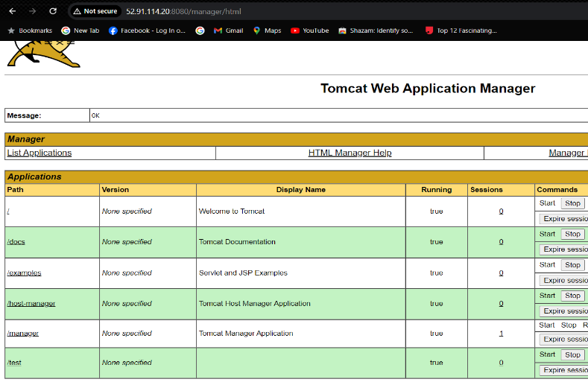

* **Now click on the test to see the application**

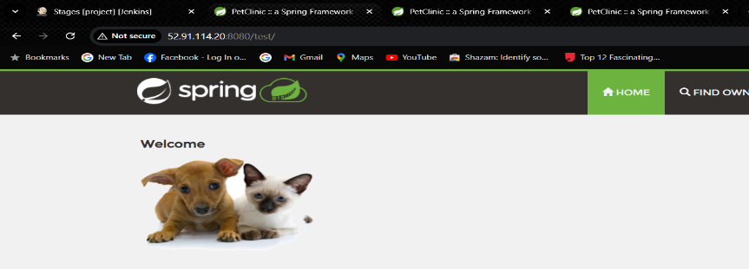

* **Pre-production in the fourth server (**[**http://3.88.20.138:8080/**](http://3.88.20.138:8080/)**)**

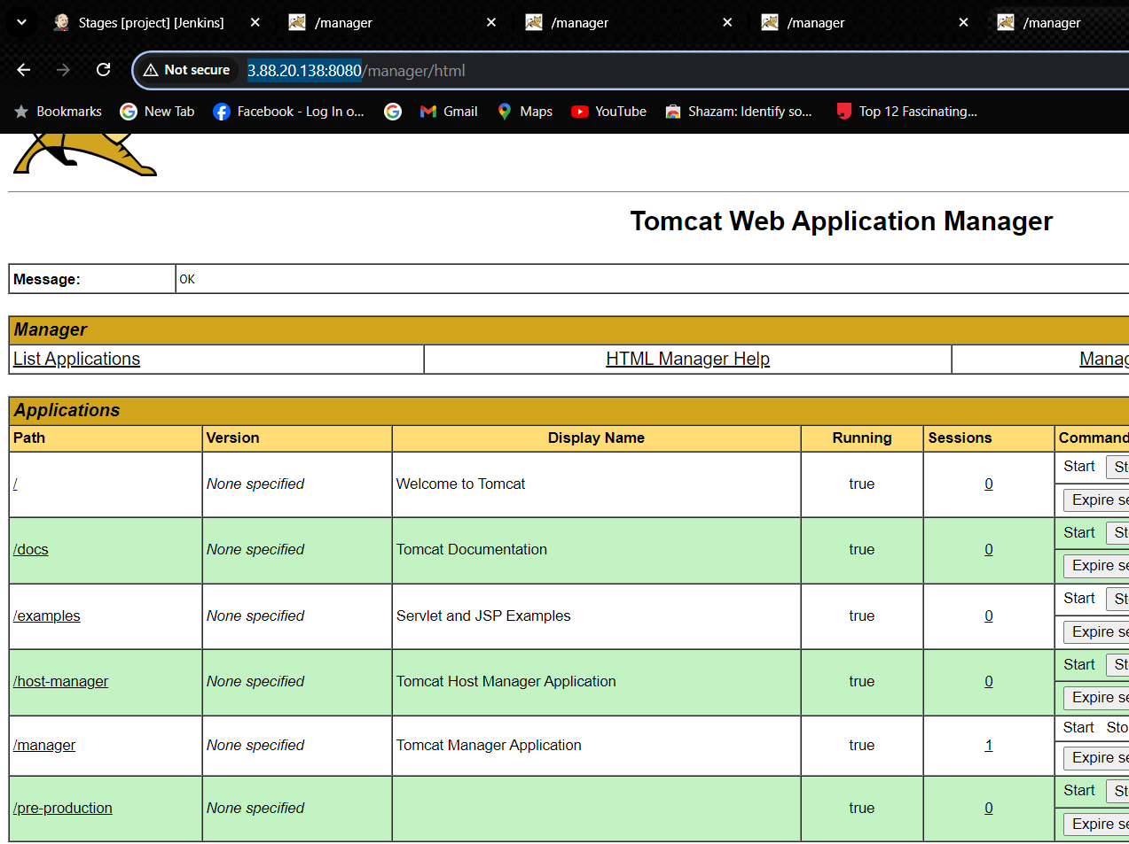

* **Now click on the pre-production to see the application**

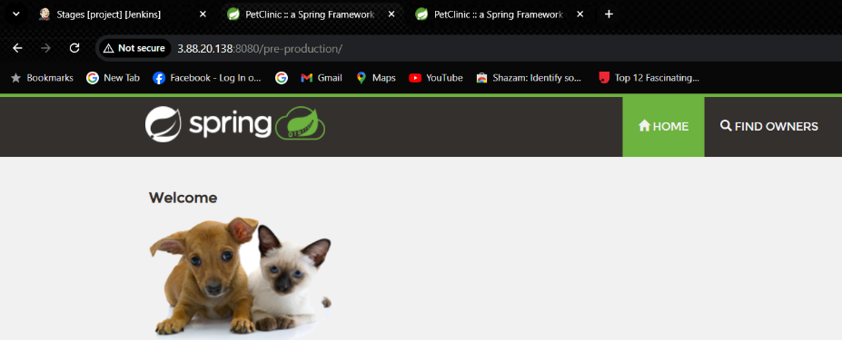

* **Production in the fifth server(**[**http://3.92.188.47:8080/**](http://3.92.188.47:8080/)**)**

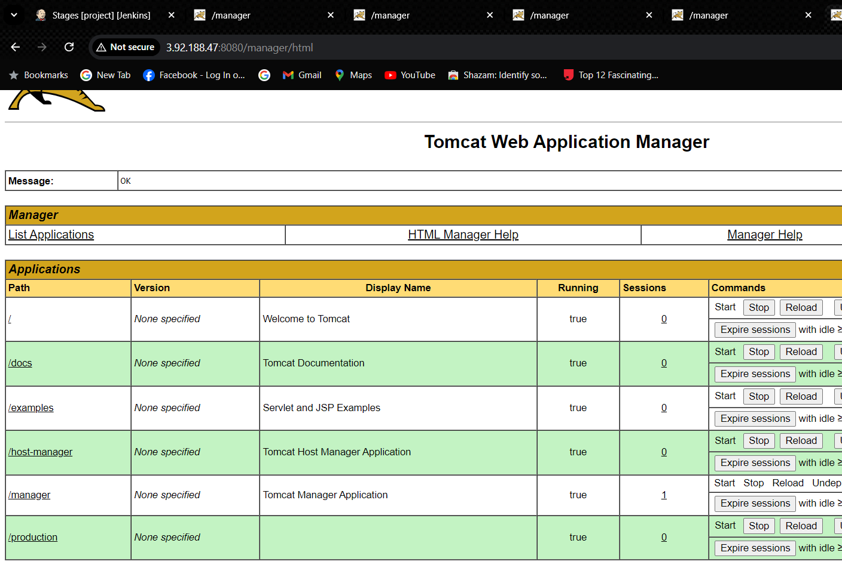

* **Now click on the production to see the application**

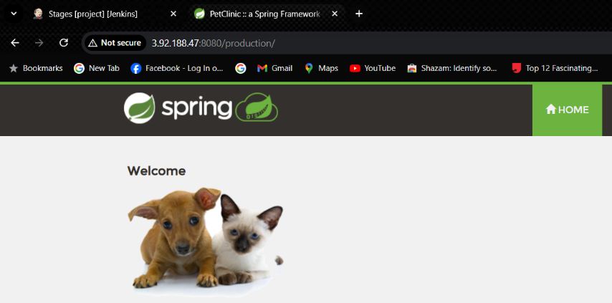

***Thank you***